DSA Lab Tasks
Task 1:
#include <iostream>
using namespace std;

class Node
{
public:
string name;
Node* left;
Node* right;

Node(string n)
{
name = n;
left = NULL;
right = NULL;
}
};

class BST
{
Node* root;
Node* insert(Node* node, string name)
{
if (node == NULL)
{
cout << "Inserted: " << name << endl;
return new Node(name);
}
if (name < node->name)
node->left = insert(node->left, name);
else if (name > node->name)
node->right = insert(node->right, name);
else
cout << "Duplicate name ignored: " << name << endl;
return node;
}

void preorder(Node* node)
{
if (node != NULL)
{
cout << node->name << " ";
preorder(node->left);
preorder(node->right);
}
}

void inorder(Node* node)
{
if (node != NULL)
{
inorder(node->left);
cout << node->name << " ";
inorder(node->right);
}
}

void postorder(Node* node)
{
if (node != NULL)
{
postorder(node->left);
postorder(node->right);
cout << node->name << " ";
}
}

public:
BST()
{
root = NULL;
}

void insertPlant(string name)
{
root = insert(root, name);
cout << "Current Inorder (sorted): ";
inorder(root);
cout << endl;
}

void displayTraversals()
{
cout << "\nPreorder Traversal: ";
preorder(root);
cout << "\nInorder Traversal: ";
inorder(root);
cout << "\nPostorder Traversal: ";
postorder(root);
cout << endl;
}
};

int main()
{
BST tree;
int n;
string plant;

cout << "Enter number of plant names to insert: ";
cin >> n;

for (int i = 0; i < n; i++)
{
cout << "Enter plant name " << i + 1 << ": ";
cin >> plant;
tree.insertPlant(plant);
}

cout << "\nFinal Tree Traversals:" << endl;
tree.displayTraversals();

return 0;
}

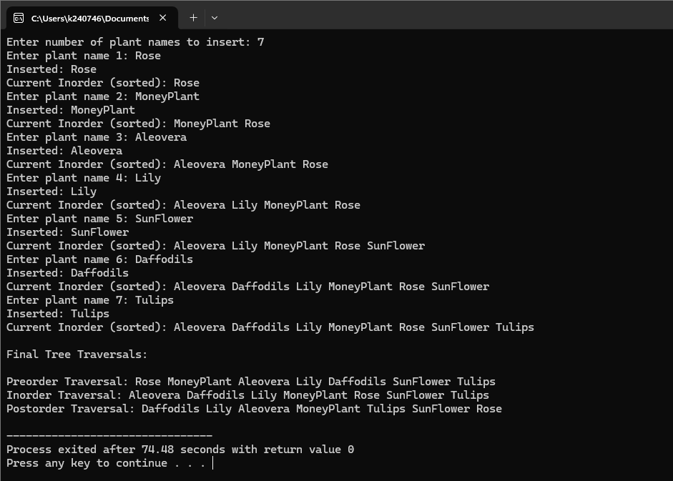
Task 2:
#include <iostream>
using namespace std;

class Node
{
public:
int id;
Node* left;
Node* right;

Node(int val)
{
id = val;
left = NULL;
right = NULL;
}
};

class BST
{
private:
Node* root;
Node* insert(Node* node, int id)
{
if (node == NULL)
{
cout << "Inserted patient ID: " << id << endl;
return new Node(id);
}
if (id < node->id)
node->left = insert(node->left, id);
else if (id > node->id)
node->right = insert(node->right, id);
else
cout << "Duplicate ID ignored: " << id << endl;
return node;
}

bool search(Node* node, int id)
{
if (node == NULL)
return false;
if (node->id == id)
return true;
else if (id < node->id)
return search(node->left, id);
else
return search(node->right, id);
}

Node* findMin(Node* node)
{
while (node && node->left != NULL)
node = node->left;
return node;
}

Node* deleteNode(Node* node, int id)
{
if (node == NULL)
{
cout << "Patient ID " << id << " not found." << endl;
return node;
}

if (id < node->id)
node->left = deleteNode(node->left, id);
else if (id > node->id)
node->right = deleteNode(node->right, id);
else
{
if (node->left == NULL && node->right == NULL)
{
delete node;
node = NULL;
}
else if (node->left == NULL)
{
Node* temp = node;
node = node->right;
delete temp;
}
else if (node->right == NULL)
{
Node* temp = node;
node = node->left;
delete temp;
}
else
{
Node* temp = findMin(node->right);
node->id = temp->id;
node->right = deleteNode(node->right, temp->id);
}
cout << "Deleted patient ID: " << id << endl;
}
return node;
}

void inorder(Node* node)
{
if (node != NULL)
{
inorder(node->left);
cout << node->id << " ";
inorder(node->right);
}
}

public:
BST()
{
root = NULL;
}

void insertPatient(int id)
{
root = insert(root, id);
cout << "Current records (Inorder): ";
inorder(root);
cout << endl;
}

void searchPatient(int id)
{
if (search(root, id))
cout << "Patient ID " << id << " found in records.\n";
else
cout << "Patient ID " << id << " not found in records.\n";
}

void deletePatient(int id)
{
root = deleteNode(root, id);
cout << "Current records (Inorder): ";
inorder(root);
cout << endl;
}
};

int main()
{
BST hospital;
int choice, id, n;

cout << "Hospital Patient Record System (BST)\n";

while (1)
{
cout << "\n1. Insert Patient IDs";
cout << "\n2. Search Patient ID";
cout << "\n3. Delete Patient ID";
cout << "\n4. Exit";
cout << "\nEnter your choice: ";
cin >> choice;

switch (choice)
{
case 1:
cout << "Enter number of patients to insert: ";
cin >> n;
for (int i = 0; i < n; i++)
{
cout << "Enter Patient ID " << i + 1 << ": ";
cin >> id;
hospital.insertPatient(id);
}
break;

case 2:
cout << "Enter Patient ID to search: ";
cin >> id;
hospital.searchPatient(id);
break;

case 3:
cout << "Enter Patient ID to delete: ";
cin >> id;
hospital.deletePatient(id);
break;

case 4:
cout << "Exiting system. Goodbye!\n";
return 0;

default:
cout << "Invalid choice. Try again.\n";
}
}

return 0;
}}